Task 2

Name- **Abhishek Mukherjee**

Reg No- **19BCE0598**

**Query**

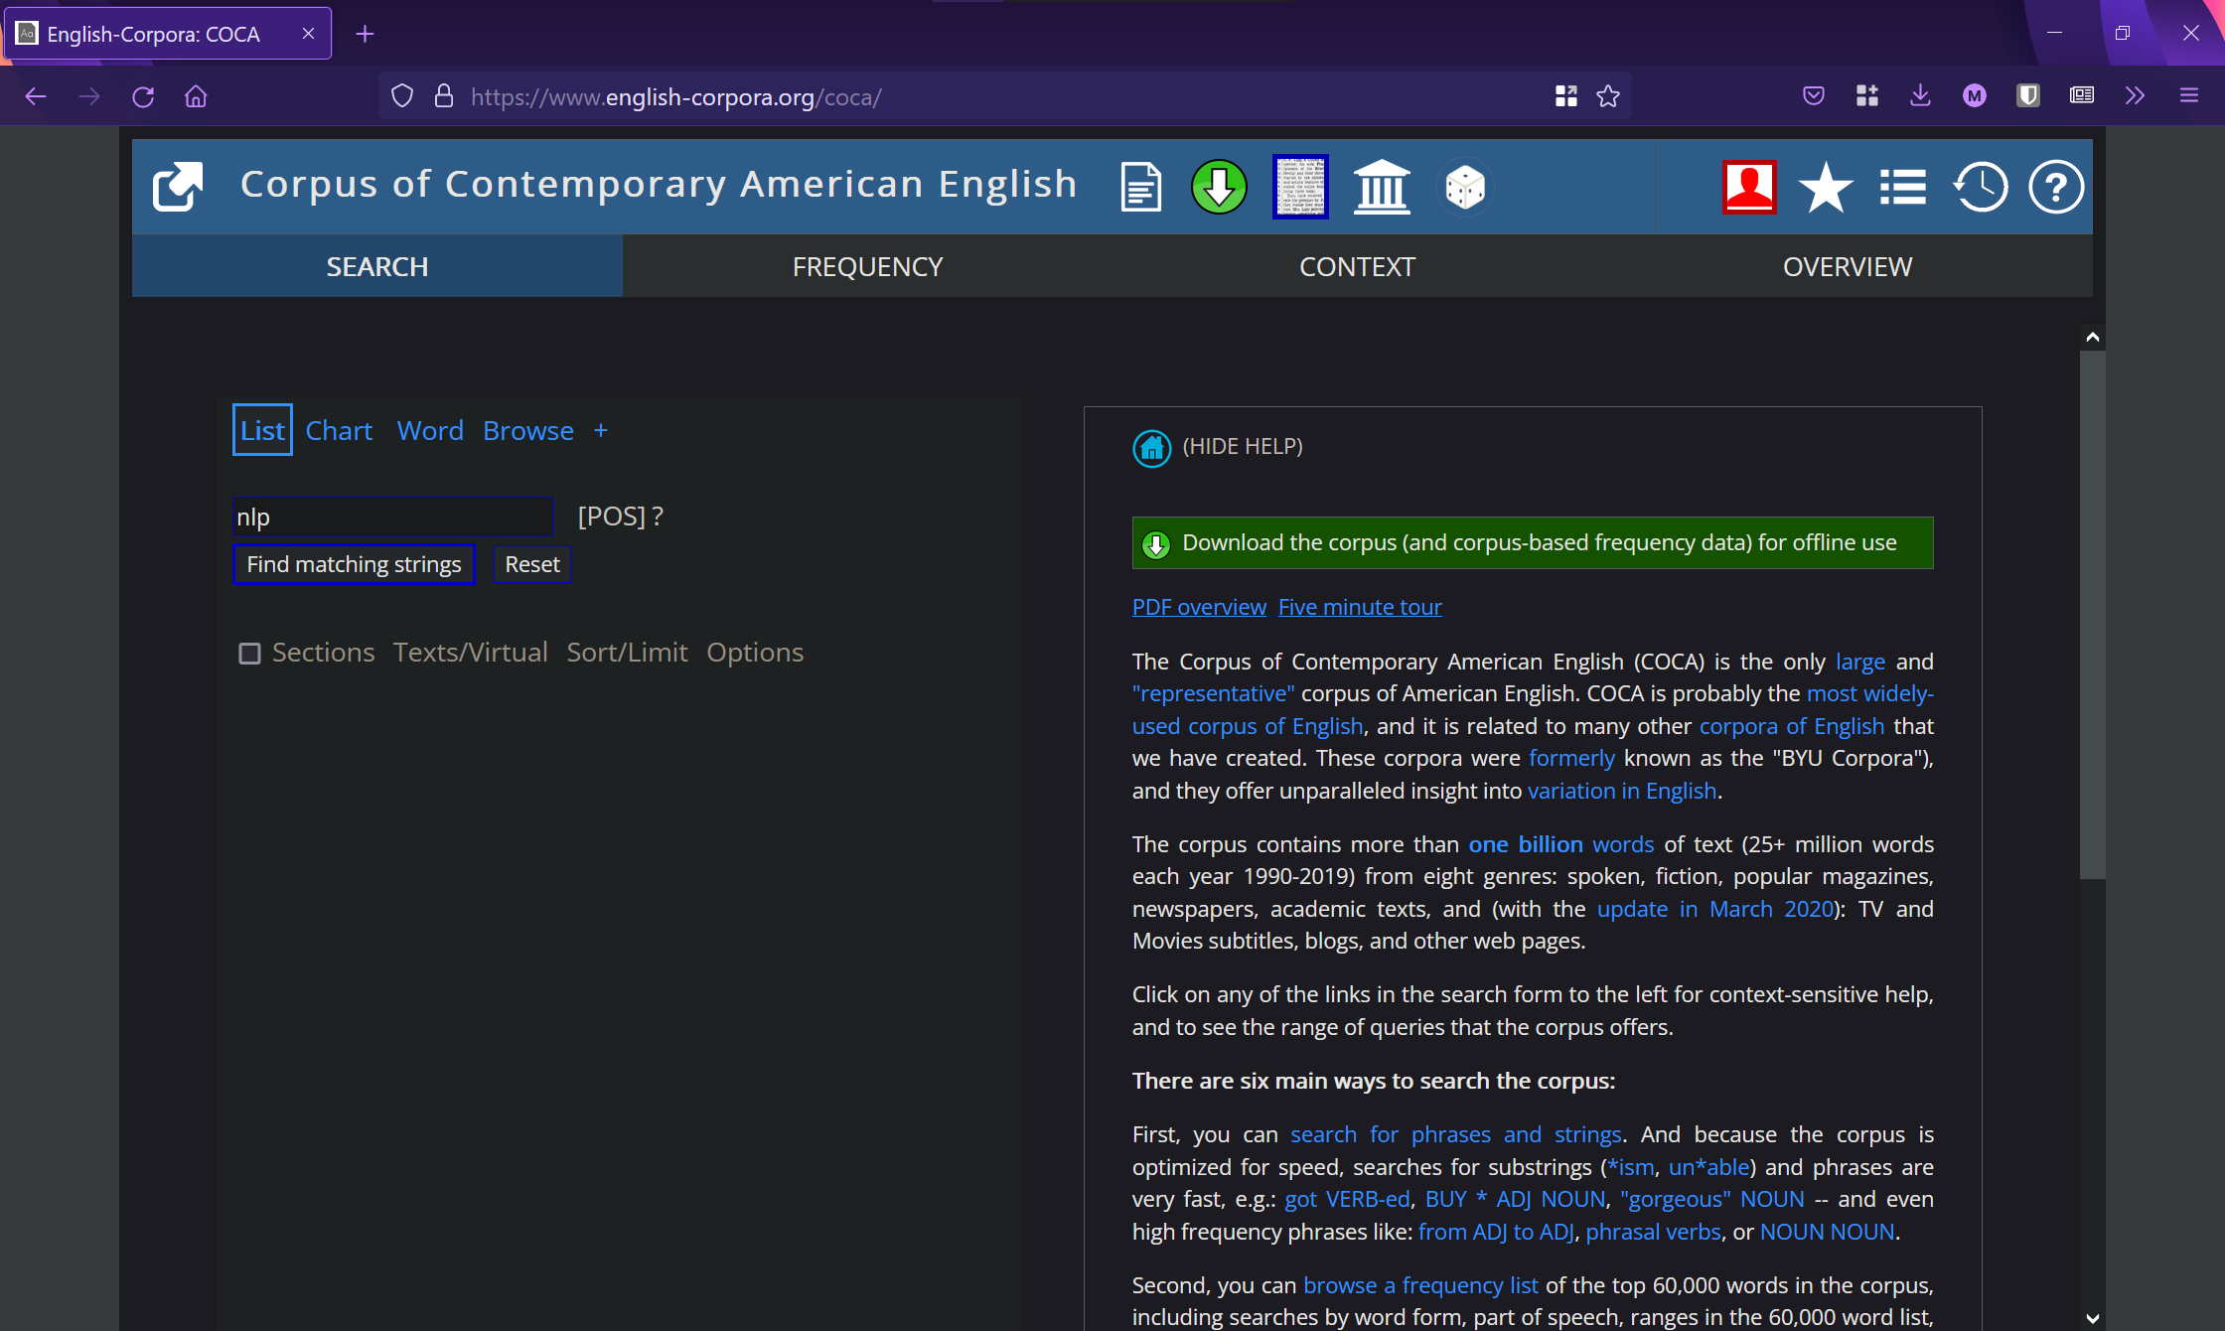

The search term in above query is ‘NLP’.

**Resultant Chart**

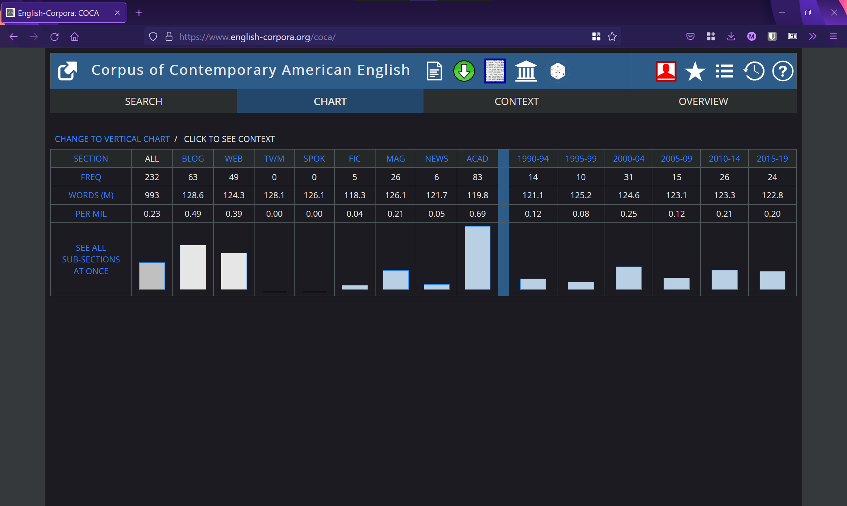

From the resultant chart above, we can infer that NLP gained traction in early 2000s-particularly 2000-2004. It has found mentions mainly in academia, blogposts and webcontent. It has negligible presence in news or media like TV and Movies. These observations make sense as NLP is a field of study in computer science and its main source of information are academic research and articles on the web.

**Concordance Search**

